Software Requirements Specification

For the Meets Web Application

Version 1.3

Revision History

|  |  |  |  |
| --- | --- | --- | --- |
| **Date** | **Version** | **Description** | **Author** |
| 24/10/2016 | 1.0 | Introduction and Overall Description added | Luca Carotenuto |
| 25/10/2016 | 1.1 | Specific Requirements (Functionality) added | Luca Carotenuto |
| 26/10/2016 | 1.2 | Specific Requirements edited, Supporting Information added | Luca Carotenuto |
| 01/11/2016 | 1.3 | Updated Use Cases | Luca Carotenuto |

Table of Contents

1. Introduction 4

1.1 Purpose 4

1.2 Scope 4

1.3 Definitions, Acronyms, and Abbreviations 4

1.4 References 4

1.5 Overview 4

2. Overall Description 4

3. Specific Requirements 5

3.1 Functionality 5

3.2 Usability 5

3.3 Reliability 5

3.4 Performance 6

3.5 Supportability 6

3.6 Des ign Constraints 6

3.7 On-line User Documentation and Help System Requirements 6

3.8 Purchased Components 6

3.9 Interfaces 6

3.9.1 User Interfaces 7

3.9.2 Hardware Interfaces 7

3.9.3 Software Interfaces 7

3.9.4 Communications Interfaces 7

3.10 Licensing Requirements 7

3.11 Legal, Copyright, and Other Notices 7

3.12 Applicable Standards 7

4. Supporting Information 7

Software Requirements Specification

# Introduction

## Purpose

This document specifies the Software Requirements of the Meets project. It includes an overall description of the application as well as a section of specific requirements. The overall description indicates general requirements of the platform whereas the specific requirements go into further details of the provided functionality, design constraints and usability.

## Scope

The SRS applies to Meets, an event platform where the user can create, view and take part of events. It is a web based software application programmed in Java. Its scope is to be a mobile first app. Subsystems include a login system associated to a guest user, a meet-interacting system associated to a member of the platform and a meet-manipulating system solely associated to a meet owner.

## Definitions, Acronyms, and Abbreviations

* ***SRS*** - Software Requirements Specification

## References

tbd

## Overview

In the following an overall description of the requirements, functionality and constraints is given. Performance and reliability requirements are stated in the Specific Requirements section.

# Overall Description

The actions a user can take are highly dependent of its role in the system. The first time a user comes to the platform he as a guest is only able to register and login.

Users that have bypassed the login screen gain access to the system in the perspective of a member. Common use cases are ones that interact with meets like viewing, joining or leaving meets.

Certain functionality is only available for users that created meets, the so called meet owners. For them meet-manipulating are accessible by functions that allow deleting and editing existing meets.

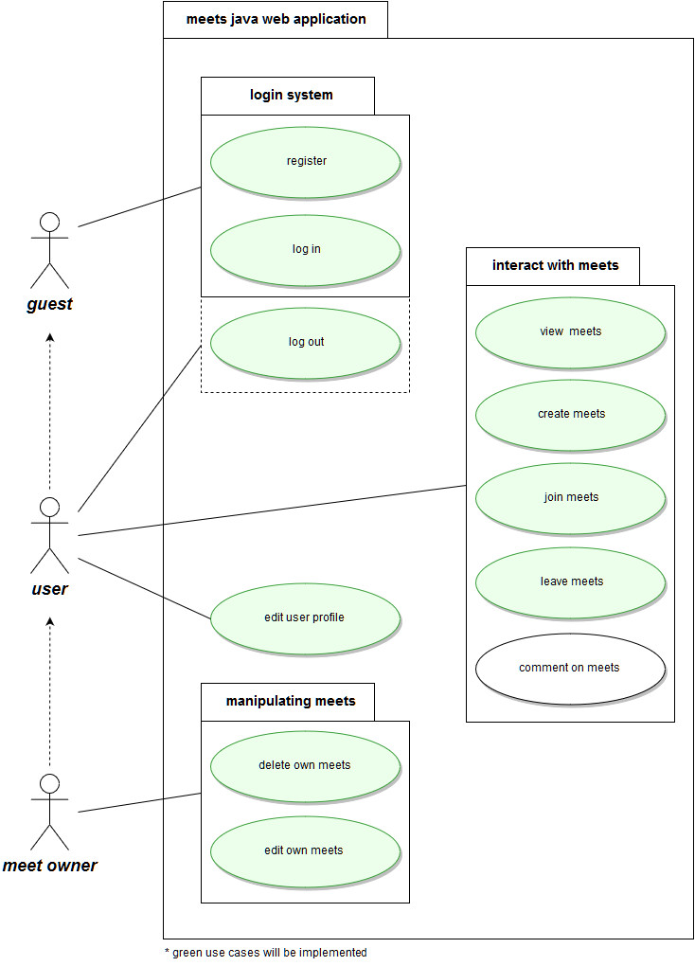

# Specific Requirements

## Functionality

The use case diagram provides an overall overview of the provided functionality. There are 3 different subsystems that group the use cases in logical groups:

* + Login system
  + Interacting with meets
  + Manipulating meets

Each one of the actors guest, user and meet owner is capable of executing specific use cases of the subsystem. In this section each use case is described in detail.

* **Login System**

***Register***

Unregistered uest users first need to register to the system in order to be able to log in to the system.

Use case specification:

<https://github.com/DaAnda97/meets/blob/master/docs/Usecase_register.docx>

***Log in***

Registered users are able to log in to the system by providing their user name and password.

***Log out***

Logged in users can log out of the system.

* **Interacting with meets**

***View meets***

Members of the platform can view meets that have been created by themselves or by other members of the community.  
  
***Create meets***

Members of the platform can create their own meets.

Use case specification:

<https://github.com/DaAnda97/meets/blob/master/docs/Usecase_create_meet.docx>  
  
***Join meets***

Members of the platform can join existing meets.  
  
***Leave meets***

Users that have joined a meet can decide to leave the meet if they are unable to attend the meet or they happened to have changed their mind.  
  
***Comment on meets***

Members of the platform can comment on meets to ask questions eg.

* **Manipulating meets**

***Delete own meets***

Users that created a meet are provided with functionality to delete the meet.   
  
***Edit own meets***

Users that created a meet are provided with functionality to edit the meet.

## Usability

### Mobile first

Primary purpose of the web application is to be viewed on mobile devices. Therefore the website will be optimized for mobile phone usage.

### Intuitive usability

Ease of use of the website is a very important requirement. The user does not need an introduction to use the website to its fullest.

## Reliability

The Server uptime is planned to be close to 100%. Certain Server issues will be inevitable, but for any planned maintenance the user base will be informed in advance so they can expect the approximate timeframe when the website will be down.

## Performance

The system’s performance is characterized by fast response times and high capacity of users online at the same time.

## Supportability

The system’s maintainability is supported by high levels of coding standard including strict naming conventions and clean code without redundant code.

Frameworks and libraries will be used for suitable use cases and will not reduce the readability of the code.

## Design Constraints

tbd

## On-line User Documentation and Help System Requirements

There is no help system for the usability of the website due to the ease of use of the website. We believe that self-explanatory functions do not need user documentations.

## Purchased Components

There will be no purchased components used in the project.

## Interfaces

tbd

### User Interfaces

tbd

### Hardware Interfaces

Devices that have an in-built web browser.

### Software Interfaces

A web browser is a requirement for viewing the website.

### Communications Interfaces

Stable internet connection.

## Licensing Requirements

tbd

## Legal, Copyright, and Other Notices

tbd

## Applicable Standards

tbd

# Supporting Information

tbd